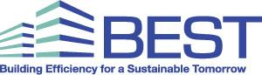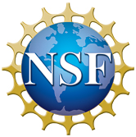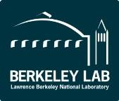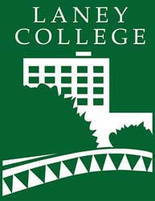

Media Contact: Pamela Wallace, BEST Center Director

900 Fallon Street, Library Room 307, Oakland, CA 94607

(510) 464-3248; [pwallace@peralta.edu](mailto:pwallace@peralta.edu)

**U.S. Community College Faculty Convene at Laney College**

**for Annual Institute on High Performance Building Technician Education**

Oakland, California – January 11, 2017 – BEST Center (Building Efficiency for a Sustainable Tomorrow) will host 37 faculty from 27 community and technical colleges from all corners of the U.S. for a 4-day Annual Institute to be held at Laney College and Lawrence Berkeley National Laboratory (Berkeley Lab). The event will be held from January 11 - 14, 2017 and is organized by BEST Center, a National Science Foundation (NSF) Advanced Technological Education (ATE) Center of Excellence based at Laney College in Oakland, CA.

##### This year’s theme is “Learning by Doing in Building Technician Education: New Technologies, Teaching Strategies, and Lab Applications,” and the focus will be on intensive hands-on exercises to demonstrate how concepts and new practices can be brought to the classroom. Berkeley Lab’s building technology scientists will share the latest research, technology, and tools. Industry experts working on some of the world’s most innovative buildings will share their experiences and insights on real world applications, scenarios, and data.

Participants will visit the regional offices of DPR Construction in San Francisco for a tour and update on maintaining Zero Net Energy buildings. At Laney College, there will be activities with Building Automation System Trainers that can be easily replicated by students. Participants will experiment with data loggers in different environmental conditions by utilizing Berkeley Lab’s FLEXLAB®, the world’s most advanced building efficiency test bed.

Institute highlights:

* “Tools & Processes for Improved Building Operations” with Michelle Daniels (US General Services Administration), Jay Santos (Facility Dynamics Engineering), and Paul Ehrlich (Pacific Northwest National Laboratory)
* “Zero Net Energy Controls Design and Facilities Management” by Janey Kaster (Honeywell) and Edmundo Martinez (DPR Construction)
* “Zero Net Energy Buildings: a Primer” by Edward Dean (Architect & author of *Zero Net Energy: Case Study Buildings, Vols. I & II*) and Can Anbarlilar (PG&E)
* “Commercial Building Energy Saver” by Kaiyu Sun, Tianzhen Hong, and Mary Ann Piette (all with Berkeley Lab)
* “Extreme Weather Conditions in the Face of Climate Change” by Michael Wehner (Berkeley Lab)

“We are fortunate to gather together educators and experts to share new innovations and best practices in the world of building efficiency,” states Peter Crabtree, BEST Center Principal Investigator and Laney College Dean of Career and Technical Education. “We are inspired by the commitment of our members and hope that the discussions on climate and building science mixed with the technical, hands-on activities will help make their own programs more effective for their students.”

The Building Efficiency for a Sustainable Tomorrow (BEST) Center supports publicly funded 2-year colleges with programs in heating, ventilation, air conditioning and refrigeration (HVAC/R), building automation controls, and energy/facilities management. Sponsored by [Advanced Technological Education](https://atecentral.net/r19658/building_efficiency_for_a_sustainable_tomorrow_best_center) grants from the National Science Foundation, this national collaborative promotes state-of-the-art building technician education and dissemination of the latest research, technology, and industry collaborations in energy efficient buildings.

For more information, go to: [www.bestctr.org](http://www.bestctr.org); [www.laney.edu](http://www.laney.edu); [www.nsf.gov](http://www.nsf.gov); [www.lbl.gov](http://www.lbl.gov)